Audio Physic Step loudspeaker
By Jack English • Posted: Apr 23, 2013 • Published: Oct 1, 1994
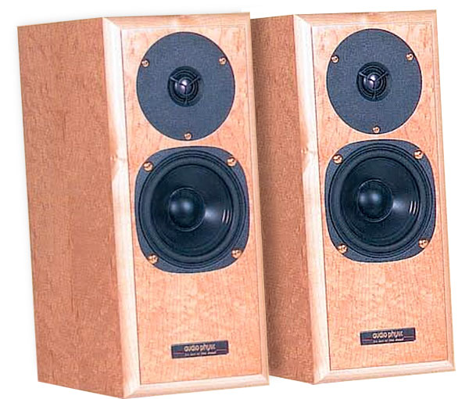
Immedia introduced the German Audio Physic speakers at the 1994 Winter CES. As I mentioned in my Show report (Vol.17 No.4), I felt the price:performance ratios of the three models displayed was an indirect one: the least-expensive—the Step—sounded best (footnote 1). Since I'm always looking for products that offer great bang for the buck, I arranged to receive a pair of review samples.
The speakers looked innocuous at first glance: typical minimonitors with two drivers—a ¾" metal-dome tweeter and a tiny woofer with a chassis just 4" across—and a rear-firing port 1.25" in diameter. But the connectors are female bananas which, though popular in Europe, have never caught on in the US. It got weirder. Each speaker has a small, oval, metal plate on the bottom near the front, and two more ovals plus a threaded tap on the back. Huh?
I unboxed the dedicated Sound Anchors stands while pondering these oddities. The stands' pile of rods, bolts, plastic caps, and different-sized spikes looked like an erector set. The owner's manual had not yet been translated into English, so I was on my own. But since there were two speakers, I figured there had to be two stands. I separated the parts into two equal piles. Assembly was actually pretty straightforward: I just lined up the holes in the various rods.
As soon as the stands were fully assembled, I understood what the speakers' three metal plates are for: they protect the speaker from the stand's support spikes, which delicately balance each speaker. The speaker is then secured with a bolt, which goes through the rear of the stand into the threaded tap on the back of the speaker. When everything was together, each three-legged stand firmly held a speaker, tilting it back slightly to help time–align the drivers.
I called Immedia's Allen Perkins and confirmed the accuracy of my setup. He went on to tell me that Sound Anchors will soon be building the stands for all Audio Physic Step speakers sold in the US—manuals and instructions will be provided for both the speakers and the stands. In addition, the female banana connectors will be replaced with Cardas binding posts, which, in all likelihood, will be more familiar, easier to use, and sonically superior. I plan to find out and report the results in a Follow-Up.
Once properly set up, the Steps looked intriguing. The combination of high-tech, tilted stands and grilleless speakers made for a modern, industrial look that most visitors to my listening room found striking.
The Step is small, but not because it's a budget product; it was specifically designed as a high-quality product for use in small listening rooms, and to perform optimally with high-quality ancillary equipment.
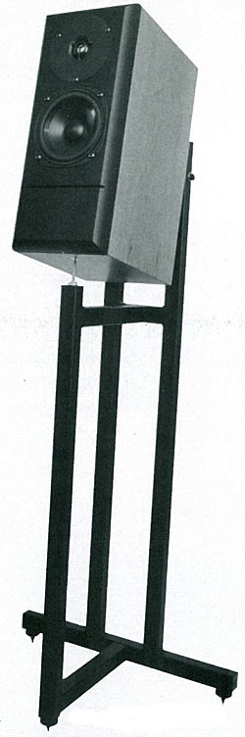
Sound
Minimonitors are unable to produce prodigious amounts of deep bass, and the Step was no exception. But the quantity and quality of the bass that was there was very impressive. In my difficult room, with the speakers a third of the way into the room from the rear wall, bass performance was strong to 60Hz, and still making noises at 20Hz. I found the bass performance from these little boxes astounding.
As expected, they were not ideal for reproducing organ music, Aerosmith, Holst's "Mars," or punk rock. The speaker's tonal balance was noticeably lightweight. The net result was a presentation that sounded slightly bright. And I wouldn't recommend them for loud parties in big rooms. But they weren't designed for any of these things.
I listened for some time with the Steps aimed directly at the listening position, taking maximum advantage of the speakers' stunning soundstaging capabilities. However, the lightweight tonal balance became fatiguing. To my surprise, the Steps were able to provide nearly the same

Audio Physic Step loudspeaker Specifications

Sidebar 1: Specifications
Description: Two-way, ported, stand-mounted loudspeaker. Drive-units: 4" (102mm) plastic-cone woofer, 0.75" (19mm) metal-dome tweeter. Measured frequency response: 60Hz–20kHz ±3dB. Measured sensitivity: 84dB/W/m. Measured impedance: 5 ohms nominal; 3.3 ohms minimum.
Dimensions: 13" (330mm) H by 5.5" (140mm) W by 9" (229mm) D.
Serial numbers of review samples: 416A/416B.

